Verlingue Limited Major Loss Response

Overview:

Verlingue recognise that it is when there is a major loss the value of the insurance policy is truly tested and it can be a very stressful time for clients as they look to keep their business moving forward. As a result the claims process can therefore be challenging, time consuming and a distraction from other competing issues that need urgent attention. It can also involve having to engage with and be questioned by experts who represent the various parts of the insurance industry.

At this time it is important, therefore, that our client has someone to guide them through the claims process, take away some of the challenges and to be there to represent their best interests at all times. As a result and as part of the overall service the Verlingue claims team are available at this time of need to fully support our clients to get back onto their feet and get the claim resolved as quickly and as simply as possible.

In order to achieve this goal, every client is provided with the following service for all high value, high profile or complex losses.

Pre-Loss:

- Contact details will be provided as to how to notify claims 24/7 direct to the Verlingue
- Access will be given to a single nominated claim professional at Verlingue who will deal with the claim from notification to settlement

Initial Response:

- The claim professional will:
  - Arrange and attend the initial site visit with the Loss Adjuster or other experts to ensure matters proceed correctly as quickly as possible
  - Lead any policy indemnity discussions in order to seek agreement at the earliest possible stage. In doing so, we will ensure that the policy wording is applied correctly and appropriately
  - Work with our client to fully assess the potential loss and claim from a material damage and business interruption perspective
  - Look to present the claim in the best manner

Subsequent Actions:

- The claim professional will:
  - Guide our client as to what can be done at each stage
  - Develop an agreed programme to move forward with all parties and agree key milestones
  - Support in any public relation / media needs the client may have
  - Ensure early and appropriate interim payments are made to keep the business operational and allow matters to progress towards settlement
  - Identify and gather all key documentation
  - Look for and advise on early settlement opportunities as appropriate
  - Support on business interruption calculations or provide the client with access of experts in this area as needed
  - Attend follow up meetings with Loss Adjusters and Insurers as required
  - Lead in successful settlement negotiations to ensure that our client’s best interests are properly represented
  - Drive the claim forward by applying tight deadlines for responses
  - Escalate as needed to achieve an outcome by using Insurer and Loss Adjuster relationships across the market
  - Ensure that throughout the claim our client will be fully updated and be aware of the next steps towards claim resolution

Introduction to Specialists:

On occasions it might be necessary to have specialist advice to support in the response to a claim in order to get the right outcome as quickly as possible. The team at Verlingue are able to make the necessary introductions for our client as needed. By way of examples that might be having access to a solicitor who specialise in policy wordings, an accountant to support on a business interruption calculation through to using the Verlingue Risk Management team to support on a health & safety issue.

The Verlingue Major Loss Claims Team
James Fairclough:
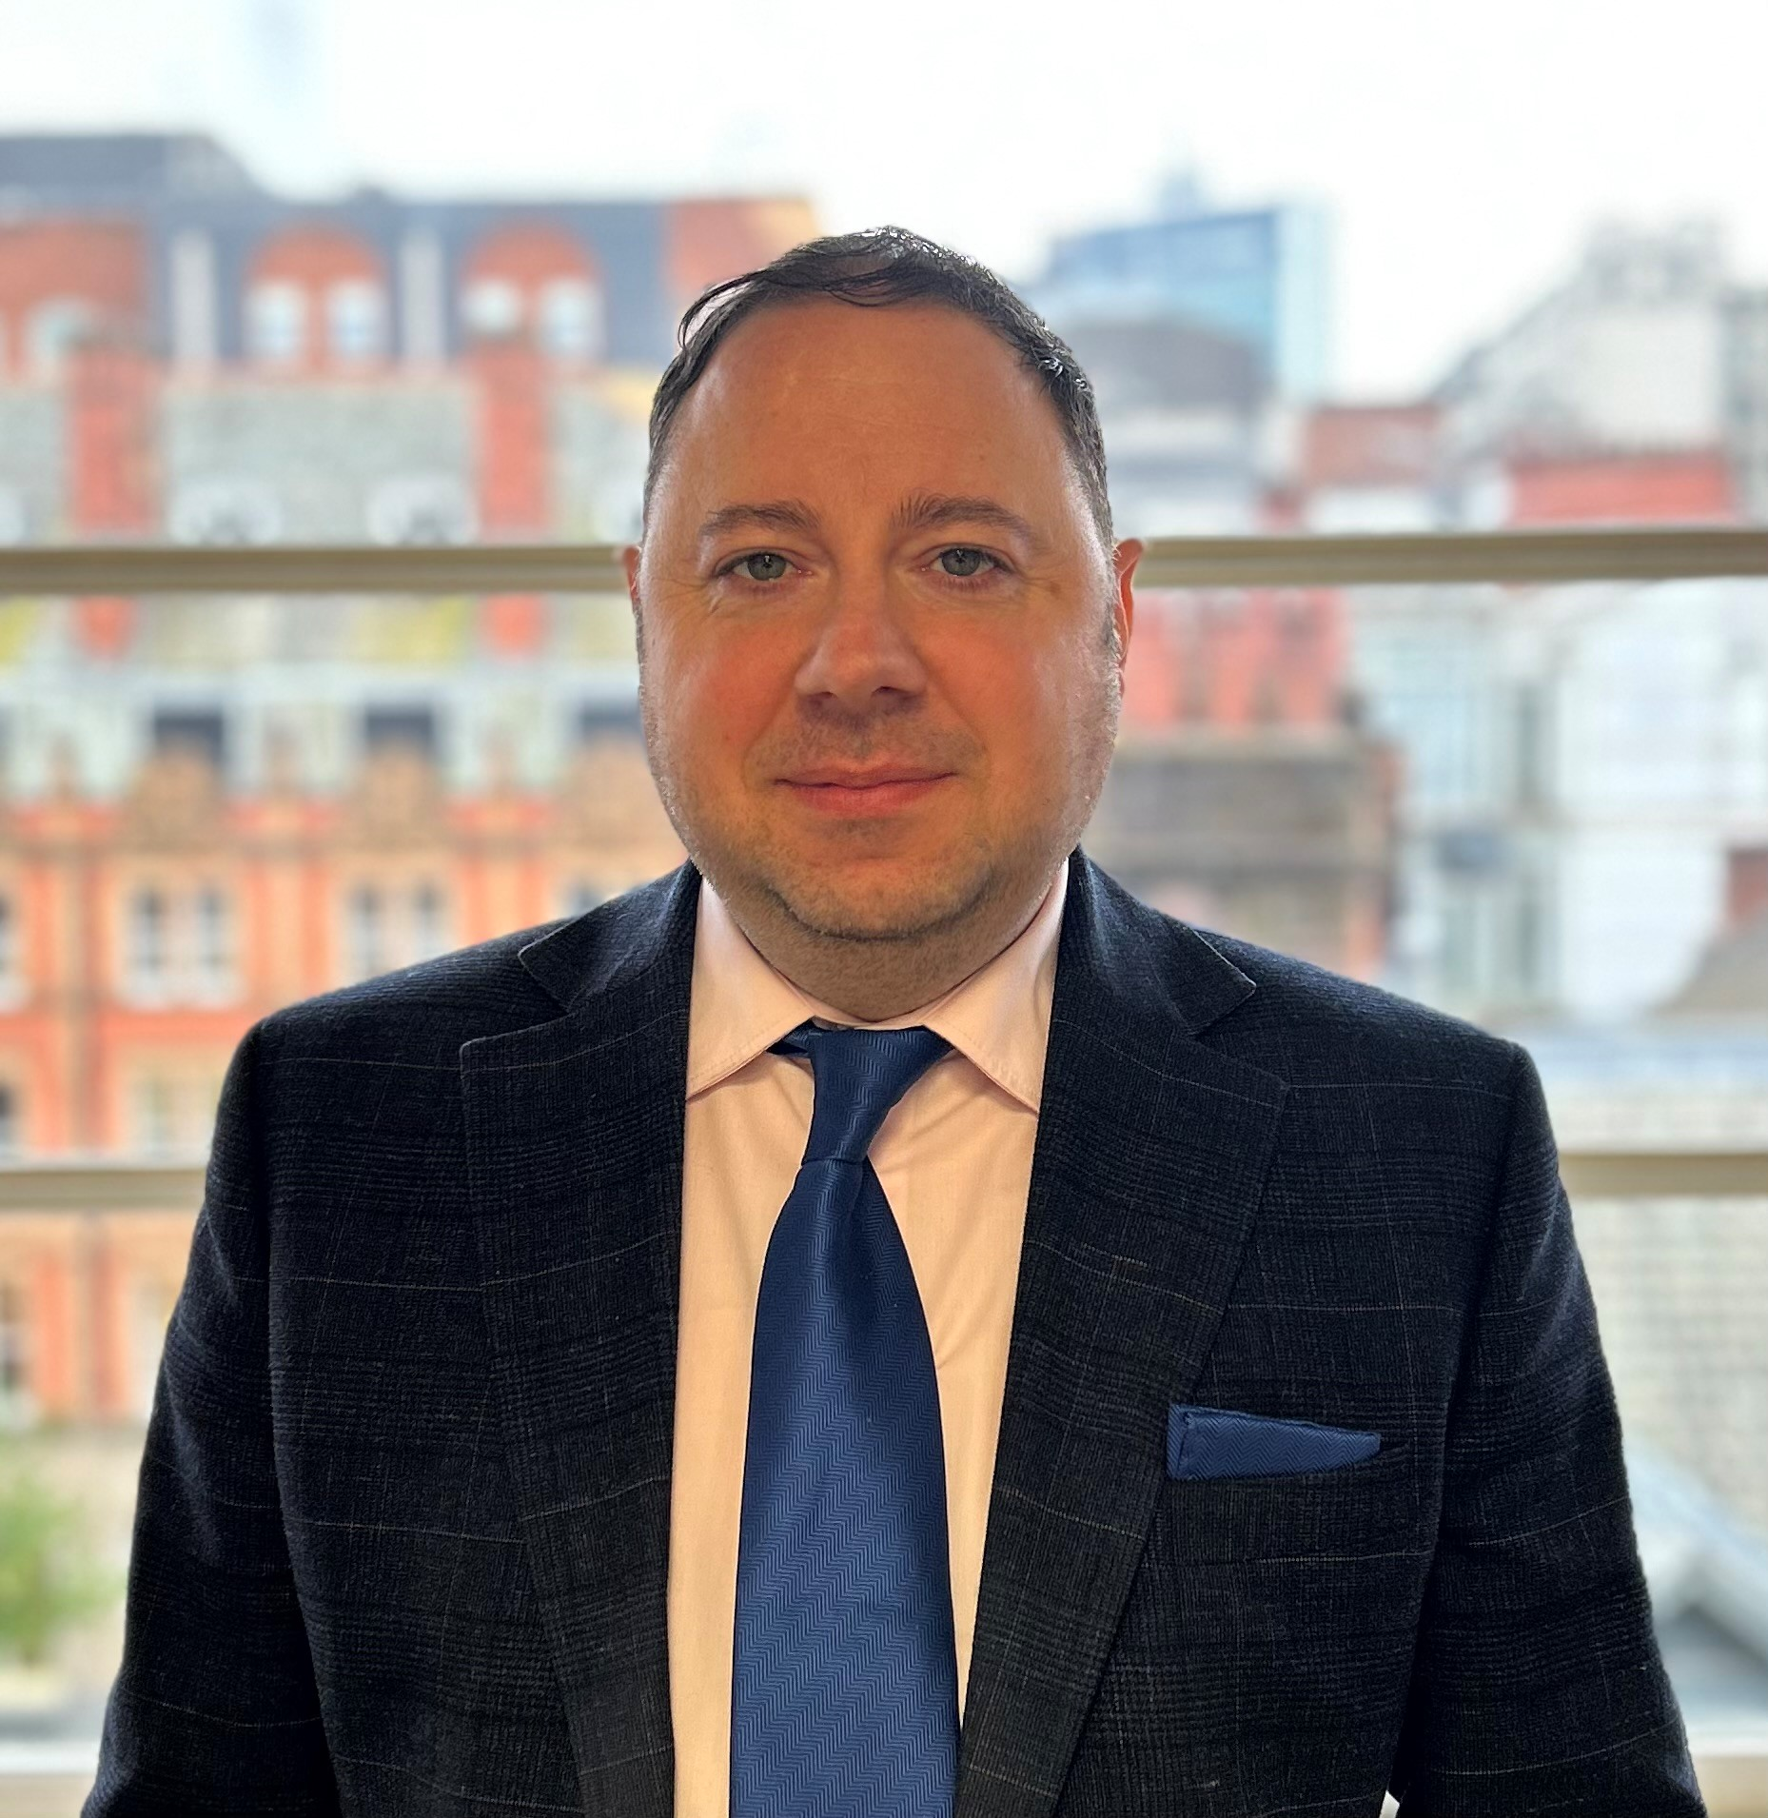
Assistant Claims Director
All commercial claims including multinational territories
T: +44 (0) 7719 053664
E: james.fairclough@verlingue.co.uk

Caroline Taylor:

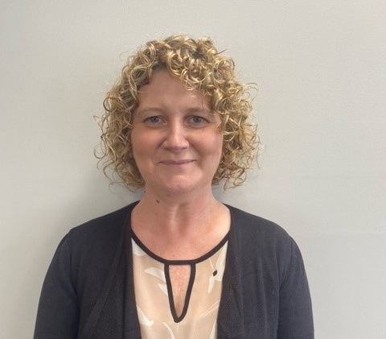
Assistant Claims Director
Affinity & Motor Schemes
T: +44 (0)208 282 8513
E: caroline.taylor@verlingue.co.uk

Gary Hoxworth:

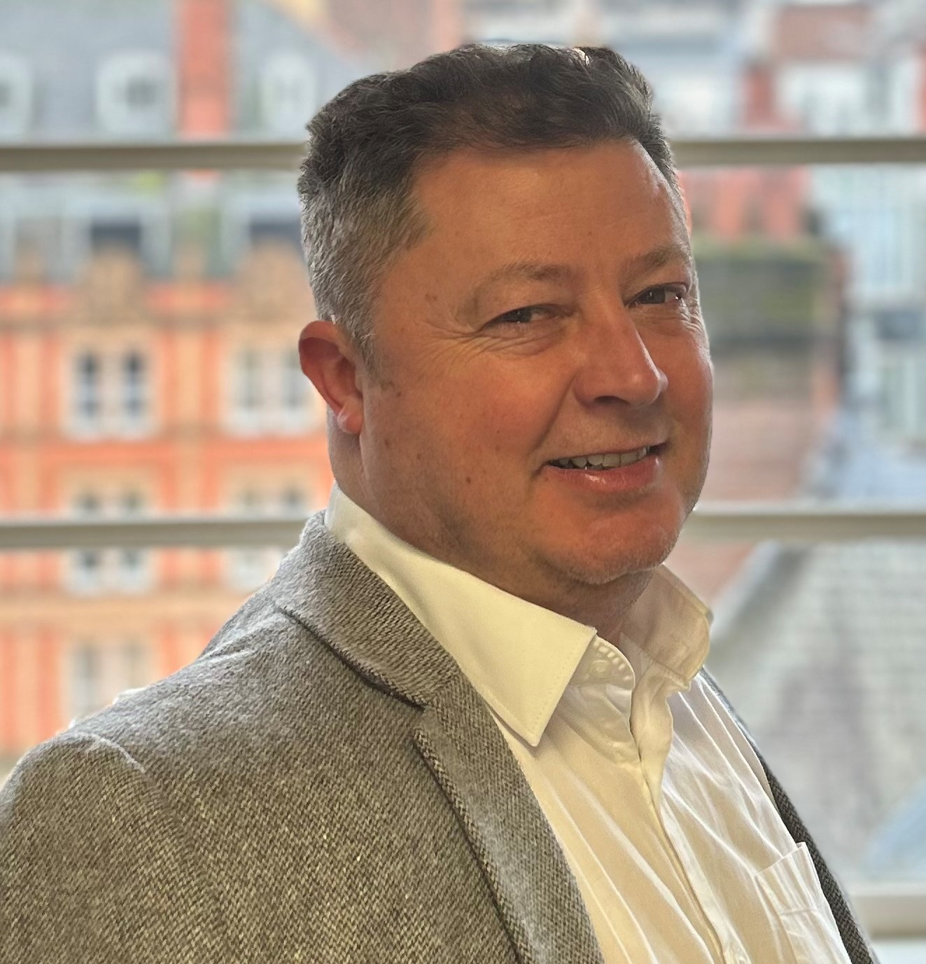
Senior Claims Executive
Large loss management and claims analytics
T: +44 (0) 7717 578 692
E: gary.hoxworth@verlingue.co.uk

Antony Hutter:

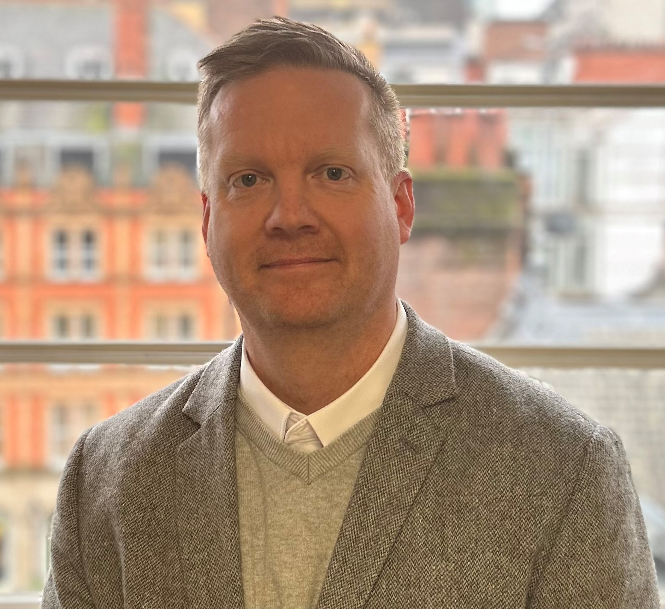
Claims Leader – Leader, Property team
Complex property & business interruption claims
T: +44 (0) 161 242 4332
E: antony.hutter@verlingue.co.uk

Sarah Bottomley:

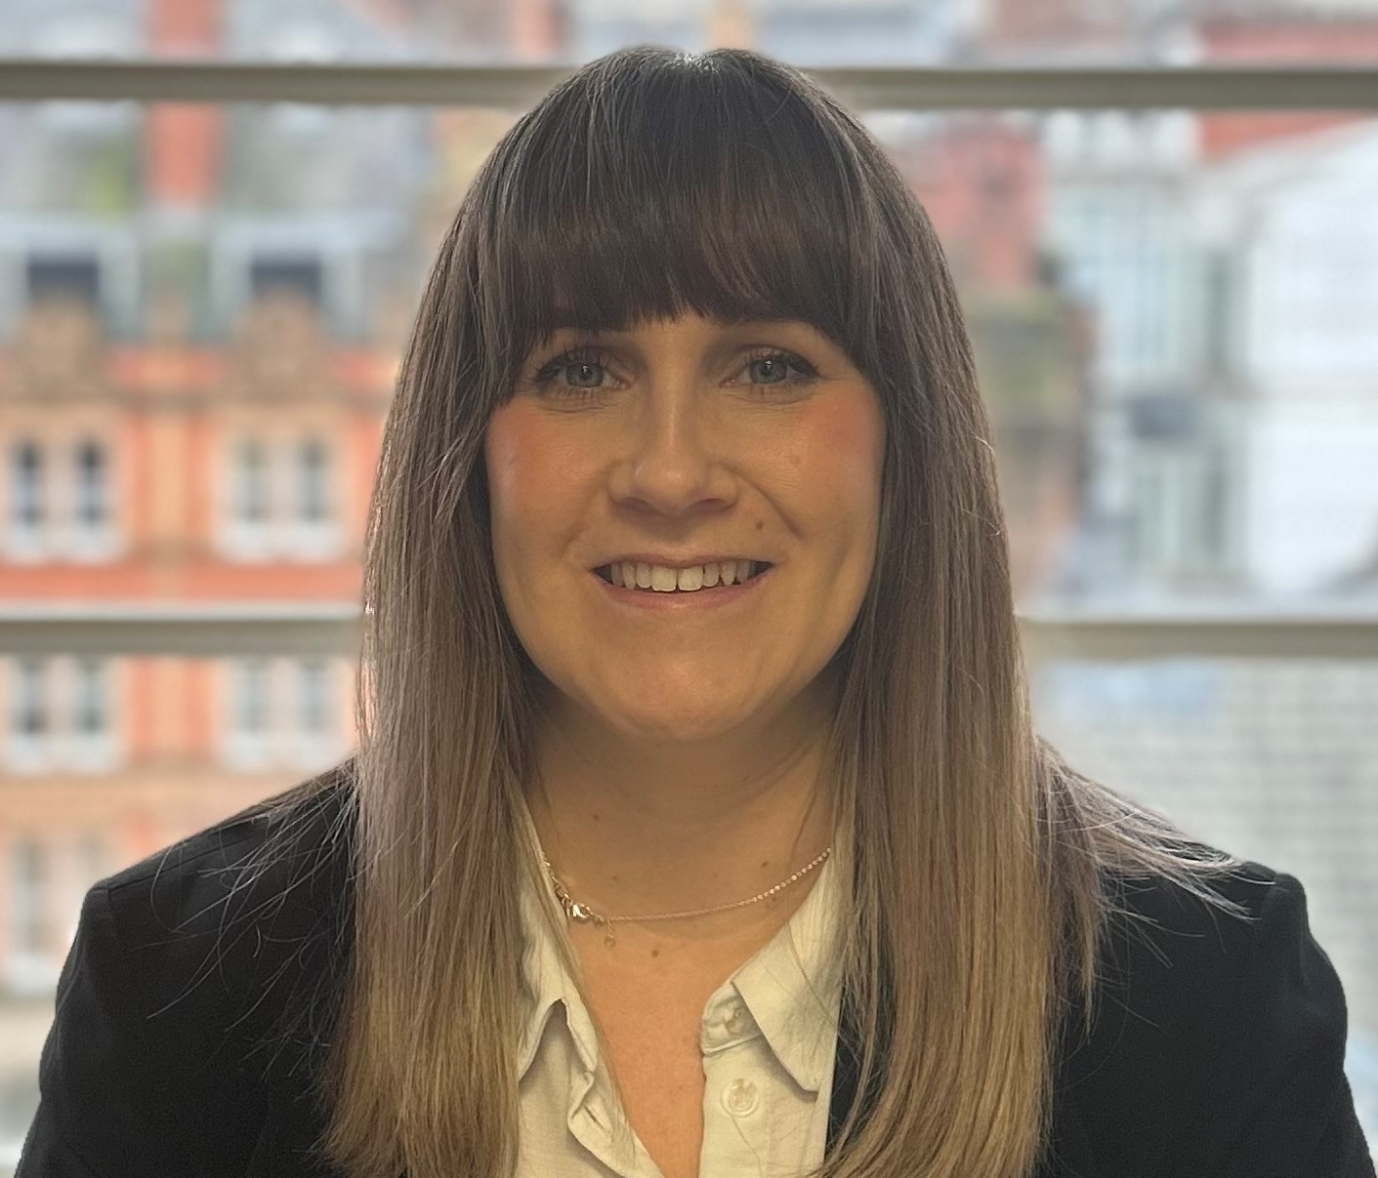
Claims Leader – Leader, Casualty team
Catastrophic casualty claims and defensibility
T: +44 (0) 161 242 4364
E: sarah.bottomley@verlingue.co.uk

Lisa Jenkinson-Carr:

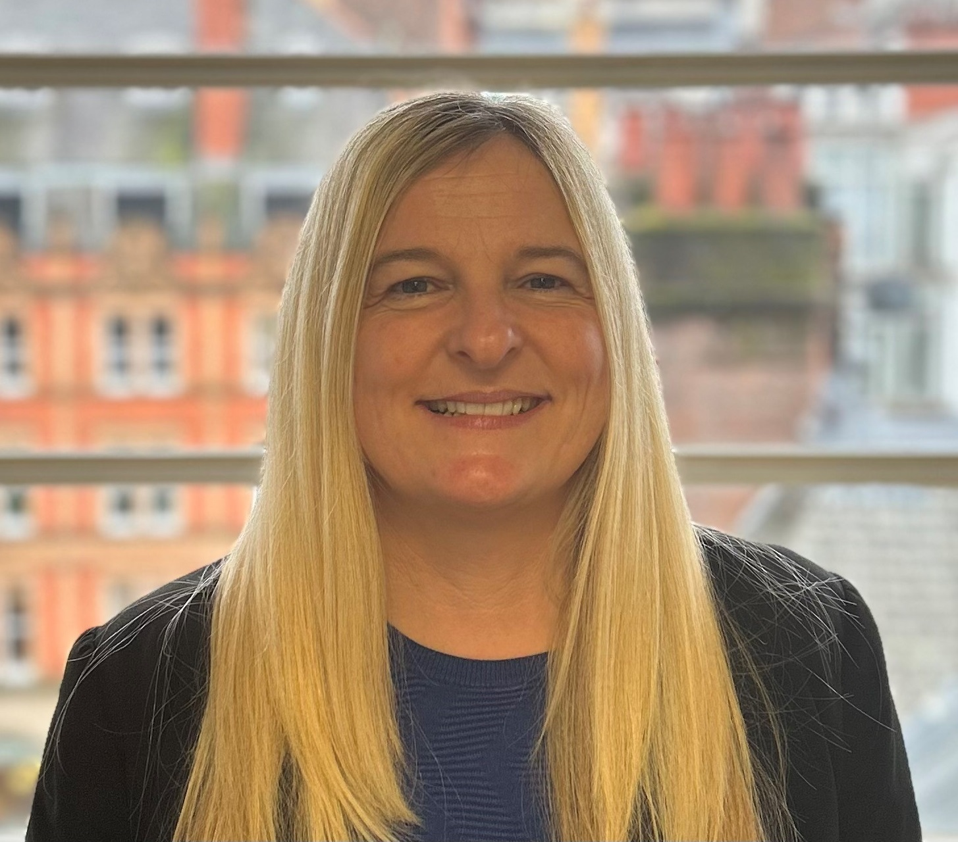
Leader, Specialty team
Complex professional and specialised financial losses
T: 0161 242 4360
E: lisa.jenkinson-carr@verlingue.co.uk

